Registration Guide
You should have already received the invitation email for the PC, together with a link to connect to the login page. The link for APacCHRIE 2019 is https://easychair.org/conferences/?conf=chriehk2019
If you have registered to use EasyChair before, you can log in using your previous login details in option (A). If you never used EasyChair before, choose the "create an account" option (B).

A

B

New Account
If you have chosen to create an account, follow the steps in the system to set up your account. Fill in the details and click Continue: now you should be correctly registered.
Step 1. Click the box “I’m not a robot” and press Continue.

Step 2. Fill in your name and email and press Continue.

An email notification will be sent to the account you have specified in the email field. Click on the link given in the notification email. You will be directed to a form where you can fill in your account details. Once you have completed the form, click "Create my account" to create your EasyChair account.

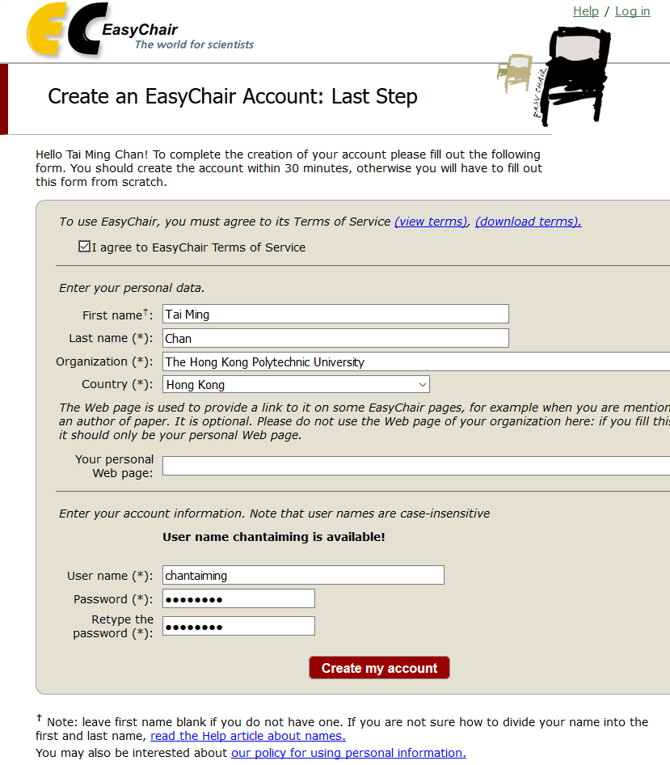

You can now log into the system with the account details that you have created. Use the link provided earlier and login to the system.

